12.Record and execute a test case for adding a product into the shopping cart

Command | Target | Value
open | https://www.amazon.in/?&tag=googhydrabk1-21&ref=pd_sl_5szpgfto9i_e&adgrpid=155259813593&hvpone=&hvptwo=&hvadid=825671333270&hvpos=&hvnetw=g&hvrand=2738987950257015347&hvqmt=e&hvdev=c&hvdvcmdl=&hvlocint=&hvlocphy=9146508&hvtargid=kwd-64107830&hydadcr=14452_2479340&mcid=e9c68a2d0f333bcaacd29ec00843c329&hvocijid=2738987950257015347--&hvexpln=nav&gad_source=1
open | https://www.google.com/search?q=amazon&rlz=1C1OZZY_enIN1131IN1133&oq=amazon&gs_lcrp=EgZjaHJvbWUqBwgAEAAYjwIyBwgAEAAYjwIyEAgBEC4YxwEYsQMY0QMYgAQyCggCEAAYsQMYgAQyBggDEEUYPDIGCAQQRRg8MgYIBRBFGDwyBggGEEUYPDIGCAcQRRg80gEINDkxMWowajSoAgCwAgE&sourceid=chrome&source=chrome.ob&ie=UTF-8
click | xpath=//div[@id='tsuid_rM_RaqHLGsOehvcPpvLNqAU_58']/div/div[2]/div/div/div/div/div/div/div/a/div/span
open | https://www.amazon.in/?&tag=googhydrabk1-21&ref=pd_sl_5szpgfto9i_e&adgrpid=155259813593&hvpone=&hvptwo=&hvadid=825671333270&hvpos=&hvnetw=g&hvrand=12620750726852792972&hvqmt=e&hvdev=c&hvdvcmdl=&hvlocint=&hvlocphy=9146508&hvtargid=kwd-64107830&hydadcr=14452_2479340&mcid=e9c68a2d0f333bcaacd29ec00843c329&hvocijid=12620750726852792972--&hvexpln=nav&gad_source=1
type | id=twotabsearchtextbox | Laptop
click | xpath=//div[@id='sac-suggestion-row-1-cell-1']/div
open | https://www.amazon.in/s?k=laptop%20under%2050k&i=aps&ref=nb_sb_ss_mvt-t11-ranker_1_6&crid=2HDLLG3TCHO7A&sprefix=laptop%2Caps%2C244
open | https://www.amazon.in/s?k=laptop+under+50k&crid=2HDLLG3TCHO7A&sprefix=laptop%2Caps%2C244&ref=nb_sb_ss_mvt-t11-ranker_1_6
click | id=twotabsearchtextbox
click | xpath=//img[@alt='Primebook 2 Pro (2026) | 8GB RAM, 128GB UFS Storage | 14.1-Inch FHD IPS Display | 14 Hours Battery | MediaTek Helio G99 | Android 15 (PrimeOS 3.0) | Backlit Keyboard | in-Built AI (Gray)']
open | https://www.amazon.in/gp/aw/d/B0FFM8M9B5?pd_rd_plhdr=t&hsa_cr_id=0&qid=1792135097&sr=1-1-941ebe59-d25b-49d0-b214-12cc5b66c90f&i=aps&aref=KGjh8RzYhZ&_encoding=UTF8&pd_rd_i=B0FFM8M9B5&ref_=sbx_be_s_sparkle_ssd_img&qid=&pd_rd_w=C5Rv7&content-id=amzn1.sym.7b6188a8-103f-4f88-b43a-19aba06e30c1%3Aamzn1.sym.7b6188a8-103f-4f88-b43a-19aba06e30c1&pf_rd_p=7b6188a8-103f-4f88-b43a-19aba06e30c1&pf_rd_r=GVJNVFGB3AJXKBJYCR4C&pd_rd_wg=Vw1Mo&pd_rd_r=1190f4a2-b6e0-413c-b332-c9bc27657e4e
open | https://www.amazon.in/gp/aw/d/B0FFM8M9B5?pd_rd_plhdr=t&hsa_cr_id=0&qid=&sr=1-1-941ebe59-d25b-49d0-b214-12cc5b66c90f&i=aps&aref=KGjh8RzYhZ&_encoding=UTF8&pd_rd_i=B0FFM8M9B5&ref_=sbx_be_s_sparkle_ssd_img&pd_rd_w=C5Rv7&content-id=amzn1.sym.7b6188a8-103f-4f88-b43a-19aba06e30c1%3Aamzn1.sym.7b6188a8-103f-4f88-b43a-19aba06e30c1&pf_rd_p=7b6188a8-103f-4f88-b43a-19aba06e30c1&pf_rd_r=GVJNVFGB3AJXKBJYCR4C&pd_rd_wg=Vw1Mo&pd_rd_r=1190f4a2-b6e0-413c-b332-c9bc27657e4e&th=1
click | xpath=//div[17]/div/span/span/span/input
open | https://www.amazon.in/cart/add-to-cart/ref=dp_start-bbf_1_glance

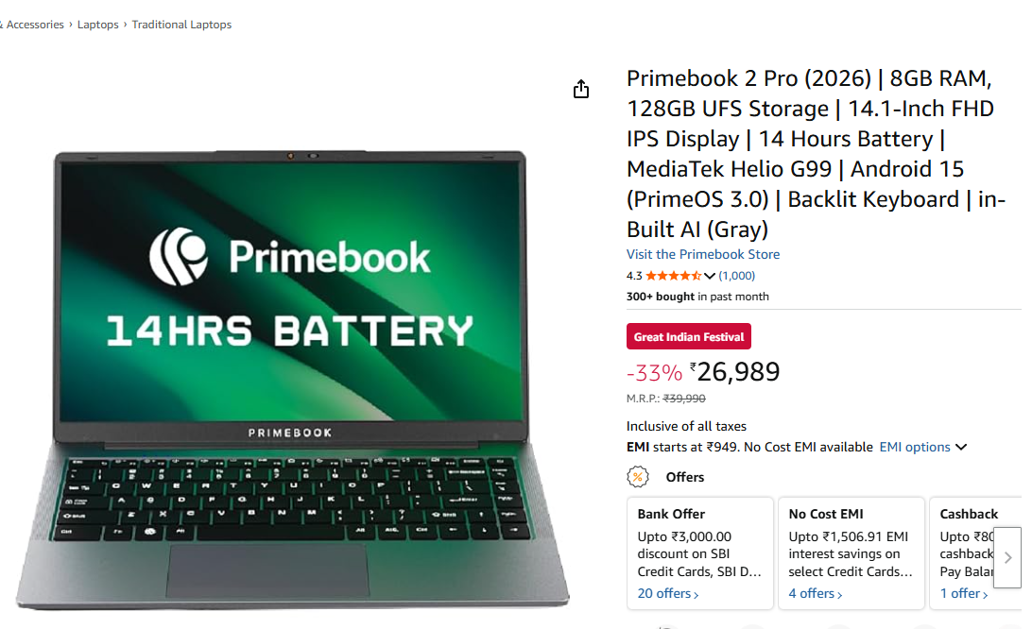

[info] Playing test case Software Testing / Practical no. 12 add a product into shopping cart

[info] Time: Fri Oct 16 2026 12:49:22 GMT+0530 (India Standard Time) Timestamp: 1792135162027

[info] OS: Windows Version: 10

[info] Browser: Chrome Version: 155.0

[info] If the test cannot start, please refresh the active browser tab

[info] Executing: | open | https://www.amazon.in/?&tag=googhydrabk1-21&ref=pd_sl_5szpgfto9i_e&adgrpid=155259813593&hvpone=&hvptwo=&hvadid=825671333270&hvpos=&hvnetw=g&hvrand=2738987950257015347&hvqmt=e&hvdev=c&hvdvcmdl=&hvlocint=&hvlocphy=9146508&hvtargid=kwd-64107830&hydadcr=14452_2479340&mcid=e9c68a2d0f333bcaacd29ec00843c329&hvocijid=2738987950257015347--&hvexpln=nav&gad_source=1 | |

[info] Executing: | open | https://www.google.com/search?q=amazon&rlz=1C1OZZY_enIN1131IN1133&oq=amazon&gs_lcrp=EgZjaHJvbWUqBwgAEAAYjwIyBwgAEAAYjwIyEAgBEC4YxwEYsQMY0QMYgAQyCggCEAAYsQMYgAQyBggDEEUYPDIGCAQQRRg8MgYIBRBFGDwyBggGEEUYPDIGCAcQRRg80gEINDkxMWowajSoAgCwAgE&sourceid=chrome&source=chrome.ob&ie=UTF-8 | |

[info] Executing: | click | xpath=//div[@id='tsuid_rM_RaqHLGsOehvcPpvLNqAU_58']/div/div[2]/div/div/div/div/div/div/div/a/div/span | |

[info] Wait until the element is found

[info] Cannot find element xpath=//div[@id='tsuid_rM_RaqHLGsOehvcPpvLNqAU_58']/div/div[2]/div/div/div/div/div/div/div/a/div/span after 1000ms switch to xpath=//div[@id='tsuid_rM_RaqHLGsOehvcPpvLNqAU_58']/div/div[2]/div/div/div/div/div/div/div/a/div/span

[info] Executing: | click | xpath=//div[@id='tsuid_rM_RaqHLGsOehvcPpvLNqAU_58']/div/div[2]/div/div/div/div/div/div/div/a/div/span | |

[info] Wait until the element is found

[info] Cannot find element xpath=//div[@id='tsuid_rM_RaqHLGsOehvcPpvLNqAU_58']/div/div[2]/div/div/div/div/div/div/div/a/div/span after 1000ms switch to xpath=(.//*[normalize-space(text()) and normalize-space(.)='Sponsored result'])[1]/following::span[1]

[info] Executing: | click | xpath=(.//*[normalize-space(text()) and normalize-space(.)='Sponsored result'])[1]/following::span[1] | |

[info] Executing: | open | https://www.amazon.in/?&tag=googhydrabk1-21&ref=pd_sl_5szpgfto9i_e&adgrpid=155259813593&hvpone=&hvptwo=&hvadid=825671333270&hvpos=&hvnetw=g&hvrand=12620750726852792972&hvqmt=e&hvdev=c&hvdvcmdl=&hvlocint=&hvlocphy=9146508&hvtargid=kwd-64107830&hydadcr=14452_2479340&mcid=e9c68a2d0f333bcaacd29ec00843c329&hvocijid=12620750726852792972--&hvexpln=nav&gad_source=1 | |

[info] Executing: | click | id=twotabsearchtextbox | |

[info] Executing: | type | id=twotabsearchtextbox | laptop |

[info] Executing: | click | xpath=//div[@id='sac-suggestion-row-1-cell-1']/div | |

[info] Executing: | open | https://www.amazon.in/s?k=laptop%20under%2050k&i=aps&ref=nb_sb_ss_mvt-t11-ranker_1_6&crid=2HDLLG3TCHO7A&sprefix=laptop%2Caps%2C244 | |

[info] Executing: | open | https://www.amazon.in/s?k=laptop+under+50k&crid=2HDLLG3TCHO7A&sprefix=laptop%2Caps%2C244&ref=nb_sb_ss_mvt-t11-ranker_1_6 | |

[info] Executing: | click | xpath=//img[@alt='Primebook 2 Pro (2026) | 8GB RAM, 128GB UFS Storage | 14.1-Inch FHD IPS Display | 14 Hours Battery | MediaTek Helio G99 | Android 15 (PrimeOS 3.0) | Backlit Keyboard | in-Built AI (Gray)'] | |

[info] Executing: | open | https://www.amazon.in/gp/aw/d/B0FFM8M9B5?pd_rd_plhdr=t&hsa_cr_id=0&qid=1792135097&sr=1-1-941ebe59-d25b-49d0-b214-12cc5b66c90f&i=aps&aref=KGjh8RzYhZ&_encoding=UTF8&pd_rd_i=B0FFM8M9B5&ref_=sbx_be_s_sparkle_ssd_img&qid=&pd_rd_w=C5Rv7&content-id=amzn1.sym.7b6188a8-103f-4f88-b43a-19aba06e30c1%3Aamzn1.sym.7b6188a8-103f-4f88-b43a-19aba06e30c1&pf_rd_p=7b6188a8-103f-4f88-b43a-19aba06e30c1&pf_rd_r=GVJNVFGB3AJXKBJYCR4C&pd_rd_wg=Vw1Mo&pd_rd_r=1190f4a2-b6e0-413c-b332-c9bc27657e4e | |

[info] Executing: | open | https://www.amazon.in/gp/aw/d/B0FFM8M9B5?pd_rd_plhdr=t&hsa_cr_id=0&qid=&sr=1-1-941ebe59-d25b-49d0-b214-12cc5b66c90f&i=aps&aref=KGjh8RzYhZ&_encoding=UTF8&pd_rd_i=B0FFM8M9B5&ref_=sbx_be_s_sparkle_ssd_img&pd_rd_w=C5Rv7&content-id=amzn1.sym.7b6188a8-103f-4f88-b43a-19aba06e30c1%3Aamzn1.sym.7b6188a8-103f-4f88-b43a-19aba06e30c1&pf_rd_p=7b6188a8-103f-4f88-b43a-19aba06e30c1&pf_rd_r=GVJNVFGB3AJXKBJYCR4C&pd_rd_wg=Vw1Mo&pd_rd_r=1190f4a2-b6e0-413c-b332-c9bc27657e4e&th=1 | |

[info] Executing: | click | xpath=//div[17]/div/span/span/span/input | |

[info] Executing: | open | https://www.amazon.in/cart/add-to-cart/ref=dp_start-bbf_1_glance | |

[info] Time: Fri Oct 16 2026 12:50:06 GMT+0530 (India Standard Time) Timestamp: 1792135206374

[info] Test case passed

